CAS PY 106

Prelecture Note 21

1. Motional emf
2. When a conducting rod is moved through a magnetic field, the magnetic field applies a force to the charged particles in the rod, because they are moving with the rod
3. The conduction electrons in the rod can respond to this force, moving such that there is a charge separation, and thus a potential difference, known as motional emf
4. In other words, motional emf is the voltage induced across a conductor moving through a magnetic field
5. If a metal rod of length L moves at velocity v through a magnetic field, motional emf is:

Motional EMF = -vLB

As long as the velocity, field, and length are mutually perpendicular

1. Which direction do positive charges deflect, if they move with a metal rod to the right in a magnetic field directed into the page?
2. 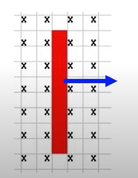

Use the right-hand rule associated with F = qvB\*sin(theta)

Positive charges deflect up, and negative charges deflect down

1. Electrons, thus, move from the top of the rod to the bottom of the rod, until enough charge builds up that there is an electric force the other way that cancels the magnetic force.
2. The moving rod acts like a battery, with positive terminal at the top
3.  🡪 🡪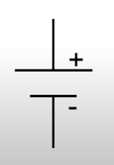
4. Acting like a battery
5. The moving rod can act like a battery if we connect it up in a circuit, like so
6. 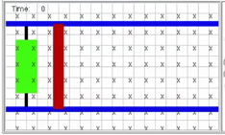
7. In a complete circuit, the moving rod can cause a current to flow:
8. 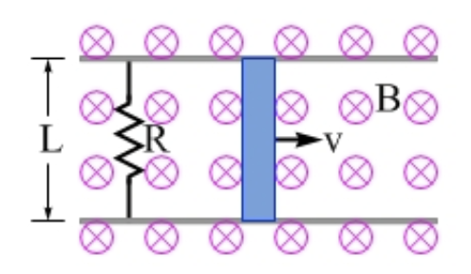
9. If the rod did not move, there would be no current. Moving the rod to the right on the rails makes the current go in one direction and moving it left makes the current go in the other direction
10. Direction of the induced current?
11. If the rod is moving to the right, will there be an induced current? If so, in what direction is it?
12. 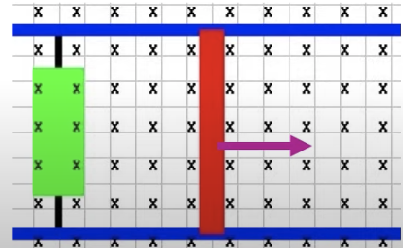
13. Apply the pictorial method
14. Before: 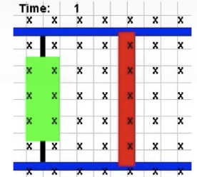
15. After: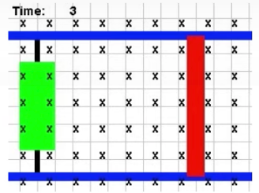
16. The animation draws the Before and After pictures for us. To oppose the change, the loop needs to create field lines out of the page, requiring a counterclockwise induced current
17. Motional EMF example
18. Let’s say the rod in the picture above is moved at a constant speed of 4m/s to the right
19. The strength of the magnetic field is 3T and the rails are 50cm apart (length of the rod)
20. The resistance in the circuit is entirely provided by 3ohm resistor on the left side of the picture
21. 
22. Calculate the magnitude of the motional emf

Emf = -vBL

Emf = - (4)(3)(0.5) = -6 volts

1. Calculate the magnitude and direction of the induced current in the loop

V = IR

I = V/R

I = 6/3 = 2 amps

One way to find the direction of the current is to apply the pictorial method. We can take the picture above to be Before picture. The After picture would be similar, except that moving the loop to the right gives a bigger loop, so there would be more field lines passing through the loop into the page

To oppose this change, the loop would create its own magnetic field directed out of the page. Applying the right-hand rule with the field out of the page gives an induced current that is counterclockwise

1. The rod is moved by you applying a force to it. How much force do you need to exert on the rod to keep it moving at 4m/s?

F = ILB = 2(0.5)(3) = 3N

You have to apply a 3N force to the right, to keep the rod moving at 4m/s

1. Calculate the power dissipated in the resistor

P = I^2\*R = 2^2\*3 = 12 Watts

1. Eddy currents
2. Current can also be induced in a solid conducting sheet.
3. Consider a metal plate. If that metal plate is exposed to a changing magnetic flux, then the conduction electrons in the plate will swirl around, giving rise to a magnetic field that opposes the change in flux.
4. These swirling currents are called eddy currents, and are analogous to the eddies in a water stream, when water sometimes swirls around as it flows downstream.
5. Eddy currents are often associated with a loss of energy.
6. If eddy currents are set up in the core of a transformer as magnetic flux is being passed from one coil to another, then that produces a drop in energy transfer, which ends up costing the power company (or the user) money.
7. On the other hand, some trains use eddy current brakes, and in that case dissipating the train's kinetic energy is exactly what is wanted.
8. The large brown circle represents a steel train wheel, rotating clockwise.
9. The driver of the train has applied the brakes, which means a magnetic field (shown here directed into the page) is passed through only a part of the wheel.
10. This is important, because the system would not work well if the entire wheel was exposed to the field.
11. 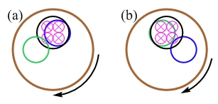
12. ​Between the picture on the left and the picture on the right, a circular region (in green) of the wheel rotates into the field, and another circular region (in blue) rotates out of the field.
13. Consider the region in green. The two images essentially show the Before and After pictures that are part of our pictorial method.
14. To oppose the change in flux, that section of the wheel has an induced current that swirls counterclockwise (these are the eddy currents).
15. 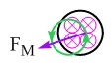
16. ​As the picture shows, there is a force down and to the left on the induced current. Looking back at the original picture, it should be clear to you that a force in that direction, applied above the middle of the wheel, will produce a torque that acts to slow the wheel.
17. It is important that the magnetic field is only acting on part of the swirling currents - if it was acting on the entire swirling current then there would be no net force.
18. Try carrying out a similar analysis of the blue region, which leaves the region of field.
19. If you do it correctly, you will find that region experiences a force up and to the left, which will also act to slow down the wheel.